James Hood

CSC 4220

Homework 3

November 1, 2017

1.

a. The source port number will be Y and the destination port number should be X.

b. Some people might have an application that sends data that can tolerate some loss, such as video streaming or audio streaming. Also some developers might not want to have to deal with TCP congestion control protocols.

2.

a. Sequence numbers are important for receivers to know whether it’s receiving a new packet or a duplicate of an already received packet.

b. Timers are important for detecting loss. If an ack message is not received within a particular window then the sender can assume a loss has been incurred, allowing it to resend the needed packets.

3.

1 11 - > carries

01010011

+ 01100110

1 11

= 10111001

+ 01110100

= 00101101

→ 1’s Complement = 11010010

1’s complement makes it easier to detect errors. The receiver knows there’s been an error if the sum contains a 0. All 1 bit errors are detected, but 2 bit errors can still go undetected.

4.

a.

Sequence number: 207

Source port number: 302

Destination port number: 80

b.

Acknowledgement number: 207

Source port number: 80

Destination port number: 302

c.

Acknowledgement number: 127

d.

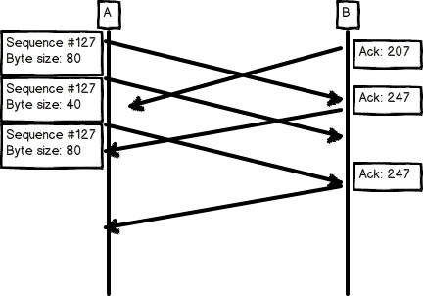

5.

a. This question is simply prefacing the following 3 questions, so it doesn’t really require elaboration.

b. Since the buffer can hold the entire file, there is no danger in being sent too much data at once.

c. There is also no packet loss and acknowledgements get sent before the timer expires, so there is no need for congestion control.

d. The sender simply can’t send much of the data at once because it’s buffer will fill up too quickly.